**CSA0674 - DAA ASSIGNMENT 6**

1. HEIGHT OF BINARY TREE AFTER SUBTREE REMOVAL QUERIES :

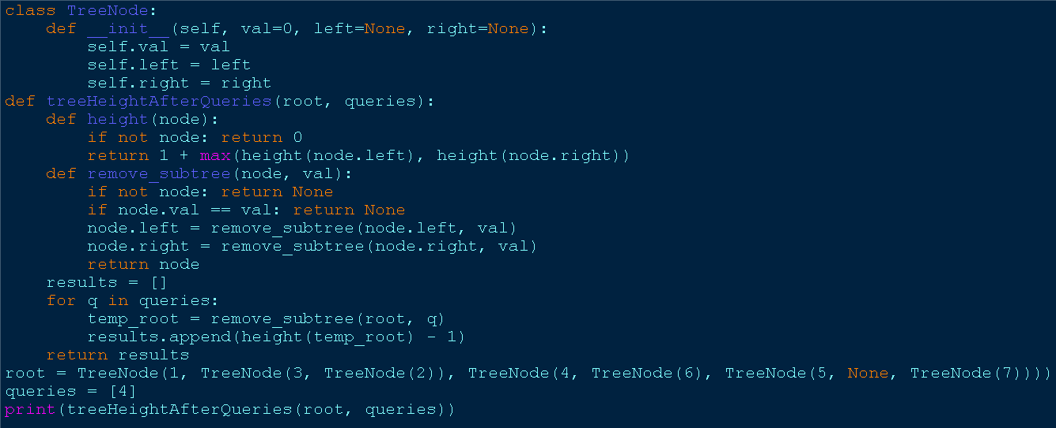

1. SORT ARRAY BY MOVING ITEMS TO EMPTY SPACE :

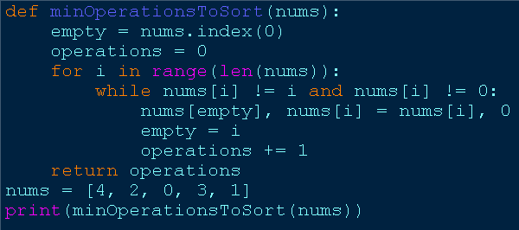

1. APPLY OPERATIONS TO AN ARRAY :

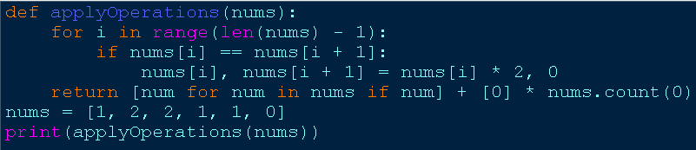

1. MAXIMUM SUM OF DISTINCT SUBARRAYS WITH LENGTH K :

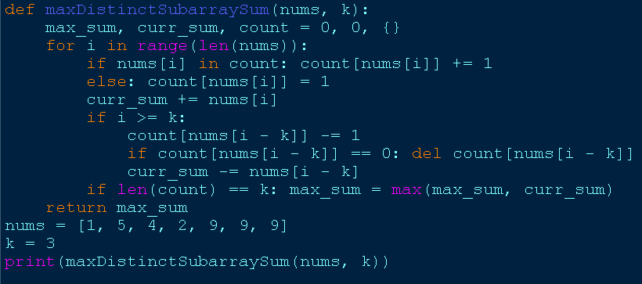

1. TOTAL COST TO HIRE K WORKERS :

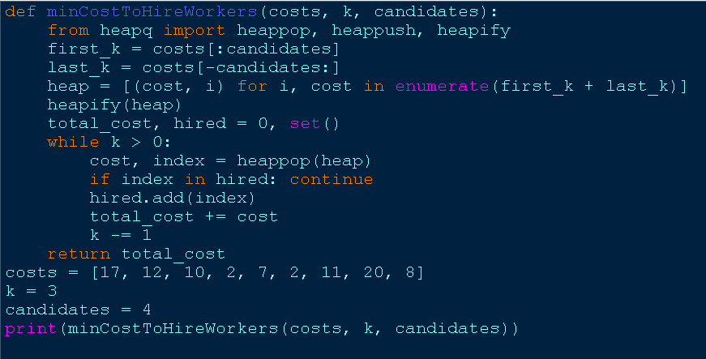

1. MINIMUM TOTAL DISTANCE TRAVELLED :

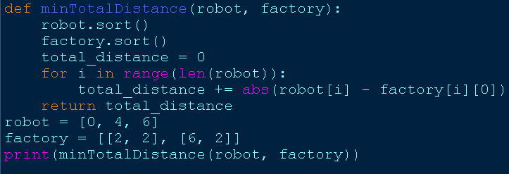

1. MINIMUM SUBARRAYS IN A VALID SPLIT :

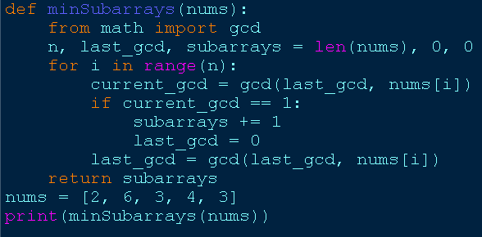

1. NUMBER OF DISTINCT AVERAGES :

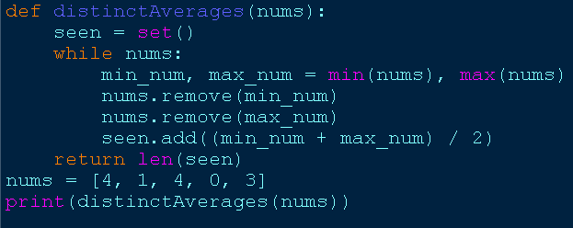

1. COUNT WAYS TO BUILD GOOD STRINGS :

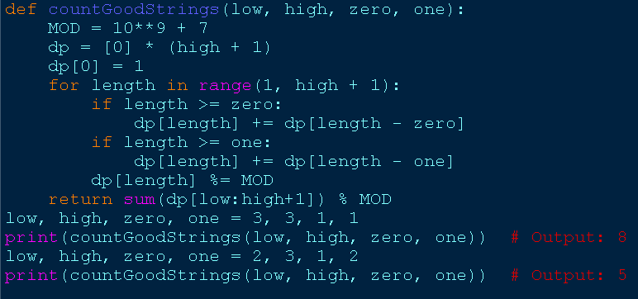

1. MOST PROFITABLE PATH IN A TREE :

